Washington EDIE/PreManage
Statewide Resource Guide

This document provides detailed description on:

Adding a Patient Care Provider
Adding Patient Background Information
Adding a Care Recommendation
Adding a Security Event

CONTENTS

Purpose Page 3

Key Recommendations Page 4

*EDIE/PreManage Care Coordination QuickGuide* Page 5
Feedback from the ED Provider Pages 7
Organizational Roles Pages 8-9
Adding Patient Care Provider Pages 10-14
Adding Patient Background Information Pages 15-25
Adding a Care Recommendation Pages 26-35
Adding a Security Event Pages 38-40
Reminders about Information Sharing Pages 41-43
Contact Information Page 44
Appendix: Care Recommendation Examples Page 45
Purpose

The purpose of this Resource Guide is to provide information that promotes the consistent use of specific EDIE/PreManage tools (Care Providers, Patient Background, Care Recommendations) to facilitate improved communication and cross organizational care coordination in Washington. This resource guide is intended to be a companion resource to the “Care Recommendations Toolkit” developed by Collective Medical Technologies. A monthly webinar “Care Recommendations for Beginners” is also available as an introduction for new users.:
Please join CMT for Care Recommendations for Beginners!
Follow the URL to attend or register:
https://collectivemedicaltech.webex.com/collectivemedicaltech/j.php?MTID=me3012d8f67b36c73a2801aad388dfce6

NOTE: The Care Provider box shown in this guide is being revised and scheduled for an update approximately fall 2017. The relevant section will be revised accordingly.
NOTE: CMT is actively working to improve the functionality for the Patient Background tabs and the Care Recommendation sections to allow for more collaboration across users and to work towards the ideal of one Care Recommendation per patient. Stay tuned for updates to this feature in 2017.
Key Recommendations
- Care Provider box—is the best place to document members of the care provider team including care managers, social workers, etc.
  - Having this information available and in a consistent place is highly valued by all care team members
- Patient Background—is the section where objective information about the patient can be collaboratively entered (e.g. Behavioral Health, Social, Substance Use).
  - This information will be sent to the ED when their EDIE notification is triggered based on criteria they define (e.g. 5 visits in 12 months, PDMP trigger, etc.)
  - Multiple care managers/coordinators can contribute information to this section rather than creating an additional care recommendation
- Care Recommendations—should include succinct, patient specific care considerations (i.e., info delivered in a hallway conversation) and care coordination information that are relevant in an ED setting
  - Ideally there should be one care recommendation for each patient, developed by the individual who has the most first-hand knowledge of the patient in collaboration with others who are involved in their care.
  - Organizations who create care recommendations should have a process established to regularly review and update the information (3-6 months)
EDIE/PreManage Care Coordination QuickGuide
Where do I ENTER specific information on a patient in EDIE/PreManage:
I want to share information about: | Care Coordination* | Medical Information | Pain/Pain Management | Behavioral Health Information** | Social Determinants of Health Information***
This information needs to be viewed by:
Emergency Department Provider | Add Patient Care Provider | Create a Care Recommendation: Care Recommendation or Pain Management sections | Create a Care Recommendation: Pain Management section | Create a Care Recommendation: Care Recommendation or Other Information sections | Create a Care Recommendation: Care Recommendation; Care Coordination; or Other Information sections
Emergency Department Care Coordinator | Add Patient Care Provider | Create a Patient Background note: Medical/Surgical | Create a Patient Background note: Medical/Surgical or Behavioral | Create a Patient Background note: Behavioral or Substance Abuse/Overdose History | Create a Patient Background note: Social
Health Plan Care Coordinator | Add Patient Care Provider | Create a Patient Background note: Medical/Surgical | Create a Patient Background note: Medical/Surgical or Behavioral | Create a Patient Background note: Behavioral or Substance Abuse/Overdose History | Create a Patient Background note: Social
Primary Care Provider or Coordinator | Add Patient Care Provider | Create a Patient Background note: Medical/Surgical | Create a Patient Background note: Medical/Surgical or Behavioral | Create a Patient Background note: Behavioral or Substance Abuse/Overdose History | Create a Patient Background note: Social
Behavioral Health Provider or Care Coordinator | Add Patient Care Provider | Create a Patient Background note: Medical/Surgical | Create a Patient Background note: Medical/Surgical or Behavioral | Create a Patient Background note: Behavioral or Substance Abuse/Overdose History | Create a Patient Background note: Social
Other | Add Patient Care Provider | Create a Patient Background note: Medical/Surgical | Create a Patient Background note: Medical/Surgical or Behavioral | Create a Patient Background note: Behavioral or Substance Abuse/Overdose History | Create a Patient Background note: Social
* Care Coordination Information = contact information for members of the patient care team
** Behavioral Health Information = mental health or substance use disorder information. DO NOT share information that is covered by 42 CFR part 2 unless the patient has expressly consented to sharing this information (see pages XX and XX for more discussion on behavioral health information)
*** Social Determinants of Health = information related to the patient’s social service needs or existing services (e.g. care givers or guardians; housing; other social service needs)
EDIE/PreManage Care Coordination QuickGuide
Where do I CONSUME specific information about a patient in EDIE/PreManage:
I want to see information related to: | Care Coordination* | Medical Information | Pain/Pain Management | Behavioral Health Information** | Social Determinants of Health Information***
I am:
Emergency Department Provider | Review Care Provider and Care Recommendation sections of EDIE Notification | Look for Care Recommendation and Medical/Surgical section of Care History in EDIE Notification | Review Pain Management in Care Recommendation section of EDIE Notification | Review Care Recommendation and Behavioral health section of Care History in EDIE Notification | Review Care Recommendation section and Social section of Care History in EDIE Notification
Emergency Department Care Coordinator | Review Care Provider and Care Recommendation sections of PreManage patient record | Review Care Recommendation and Medical/Surgical Patient Background sections of PreManage patient record | Review Pain Management in Care Recommendation section of PreManage patient record | Review Care Recommendation and Behavioral Health Patient Background section of PreManage patient record | Review Care Recommendation and Social Patient Background section of PreManage patient record
Health Plan Care Coordinator | Review Care Provider and Care Recommendation sections of PreManage patient record | Review Care Recommendation and Medical/Surgical Patient Background sections of PreManage patient record | Review Pain Management in Care Recommendation section of PreManage patient record | Review Care Recommendation and Behavioral Health Patient Background section of PreManage patient record | Review Care Recommendation and Social Patient Background section of PreManage patient record
Provider or Care Coordinator (e.g. Primary Care, Behavioral Health) | Review Care Provider and Care Recommendation sections of PreManage patient record | Review Care Recommendation and Medical/Surgical Patient Background sections of PreManage patient record | Review Pain Management in Care Recommendation section of PreManage patient record | Review Care Recommendation and Behavioral Health Patient Background section of PreManage patient record | Review Care Recommendation and Social Patient Background section of PreManage patient record
Other | Review Care Provider and Care Recommendation sections of PreManage patient record | Review Care Recommendation and Medical/Surgical Patient Background sections of PreManage patient record | Review Pain Management in Care Recommendation section of PreManage patient record | Review Care Recommendation and Behavioral Health Patient Background section of PreManage patient record | Review Care Recommendation and Social Patient Background section of PreManage patient record
* Care Coordination Information = contact information for members of the patient care team
** Behavioral Health Information = mental health or substance use disorder information. DO NOT share information that is covered by 42 CFR part 2 unless the patient has expressly consented to sharing this information (see pages XX and XX for more discussion on behavioral health information)
*** Social Determinants of Health = information related to the patient’s social service needs or existing services (e.g. care givers or guardians; housing; other social service needs)
Feedback from the ED Provider
[HOLD For Comments from WA ED Providers about these tools]
Organizational Roles
EDIE and PreManage users often ask—“how do we determine which organization does what?” This will often depend on the community and which organizations are involved in managing high risk, high need populations. The following roles are suggested as a default—acknowledging that the best results will be realized from organizations defining together what their respective roles should be in a community or region. Organizational roles are also addressed within this resource guide for each applicable tool (i.e., care providers; Patient Background; care recommendation).
Emergency Department:
- Contributes relevant objective information to the Patient Background section (shared space)
- Is incentivized to create a care recommendation when the patient is a frequent visitor of that emergency department (ED) (defined by 5 or more visits at that ED in 12 months)
- When creating a care recommendation, the ED should make its best effort to collaborate with any other known care providers (primary care, BH, health plan)
- EDIE notifications should display the most recent care recommendation developed first regardless of author
Primary Care:
- Contributes relevant objective information to the Patient Background section (shared space)
- Takes the lead on the development of the care recommendation for established patients in collaboration with other known care providers (including ED(s) where patient has most often been seen)
Behavioral Health:
- Contributes relevant objective patient information in the Patient Background section (Behavioral Health, Substance Use)
- Contacts care providers who have developed care recommendations to contribute information
- May take the lead on developing care recommendation for patients where they have the primary relationship (e.g., SPMI)
Health Plan:
- Contributes relevant objective information to the Patient Background section (shared space)
- Collaborate and coordinate with other providers and agencies

Adding Patient Care Provider

NOTE: The Care Provider box is being revised by CMT (the EDIE/PreManage vendor) and scheduled for an update in Q3 2017. This section will be updated accordingly.

Organizational Roles

Care Provider Data Entry*:  - PreManage care manager/coordinator (primary care, behavioral health, plan)  - ED care managers/coordinators | Priority Audience (Data Consumers):  - ED Providers  - ED care managers/coordinators  - PreManage care manager/coordinator (primary care, behavioral health, plan)

* This refers to manual entry of information into the EDIE or PreManage web portal. Information on care providers is also populated in this section from automated enrollment file uploads (PreManage customers) and HL7 hospital encounter messages. NOTE: The updated Care Team section will prioritize manual data entry so that this information is protected from these other data sources updating.

On the Patient Record, click the “Add Provider” button as shown in the below screenshot.

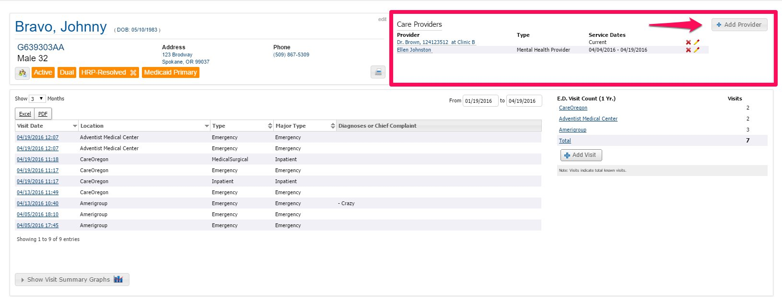

The following dialog box will display once you click “Add Provider”. Follow the steps as indicated below to add a provider.
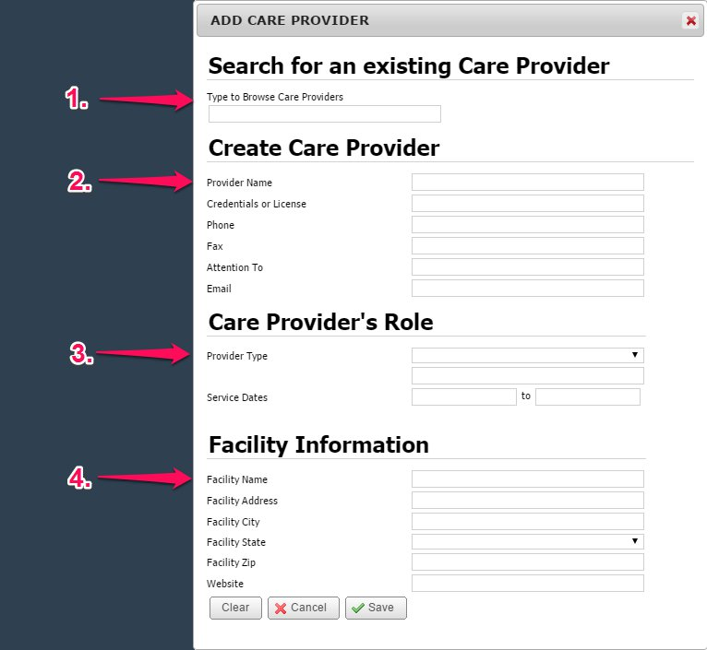

- You can search for an existing Provider here.

- If you can’t find them in the existing database, you
can create a provider. Feedback from Washington
users indicates that the following data fields are
needed at a minimum:
- Provider Name
- Phone, Fax, or Email (as many as available)
- Service dates (preferably both, but at least
Start date)
- Provider Type (dropdown menu)

- Adding the facility information is also very helpful
and valuable for the ED to see (e.g., Facility Name:
Molina)

Here is an example of what this dialog box will look like if filled in completely.
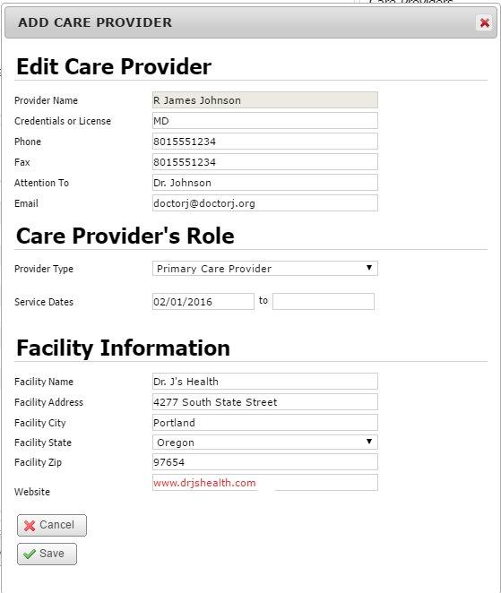
A few things to note:
- The ‘Provider Type’ drop-down provides many different
identifiers:
  - Other:
  - Hospital
  - Narcotics Prescriber
  - Pharmacy
  - Primary Care Provider
  - Specialist
  - Mental Health Provider
  - Case or Care Manager
  - Social Worker
  - Dentist

- If the ending service date is left open, it will display as
“current” on the patient record.

- If the ending service date is filled in, it will display in the
record and continue to display after end date. NOTE:
provider records are not removed after the end date has
passed. Users will need to remove outdated providers
manually.

Finally, this is what the Care Provider section will display in the PreManage patient record now that you’ve added the new provider.
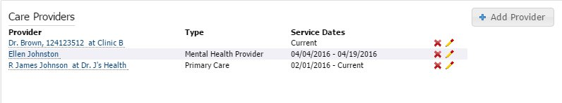

The current tool has no logic for ordering the providers on display in this section. For example, even though we just created Dr. Johnson, he is the last provider to display.

For reference, the below screenshot is how the ED will see this information (taken from an EDIE Notification). The Care Providers section on the EDIE notification will only display CURRENT providers. In this example, there are only two providers on the notification (since the other provider has an end date of 04/19/2016) as opposed to the three on the PreManage patient record (shown in the above screenshot).

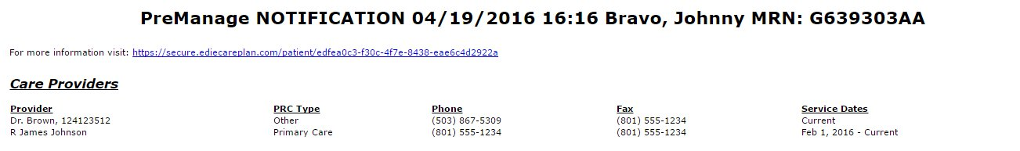

Adding Patient Background Information

Organizational Roles

Care Provider Data Entry*:  - PreManage care manager/coordinator (primary care, behavioral health, plan)  - ED care managers/coordinators | Priority Audience (Data Consumers):  - ED care managers/coordinators  - PreManage care manager/coordinator (primary care, behavioral health, plan)

- The Patient Background section is collaborative in nature: this means multiple care managers/coordinators across different organizations can contribute information to this section rather than creating an additional care recommendation

- Note: The Patient Background Section is optional in an ED alert—hospitals can choose whether or not to see this in their EDIE report. Also note that an active Patient Background section on a patient does NOT trigger an EDIE alert independently of other criteria

- The Patient Background Section is for objective information (“just the facts”) related to the patient’s history.

- There are 6 different subsections or ‘tabs’ that allow you to organize the type of information you’d like to include:
  - MEDICAL/SURGICAL
  - INFECTION/CHRONIC
  - SUBSTANCE ABUSE/OVERDOSE
  - BEHAVIORAL
  - SOCIAL
  - RADIATION

- On the following pages, each of these tabs is explained and example entries are provided.
The first section is MEDICAL/SURGICAL

- Audience: ED Provider
- Limit this section to objective information about:

  - Medical diagnoses
  - Previous surgeries that are relevant for the ED to know
  - Any Rx Allergies or other Alerts
    - You can take advantage of the ability to bold/italicize/underline very important info

See the screenshot below for an example of what this might look like for a patient:

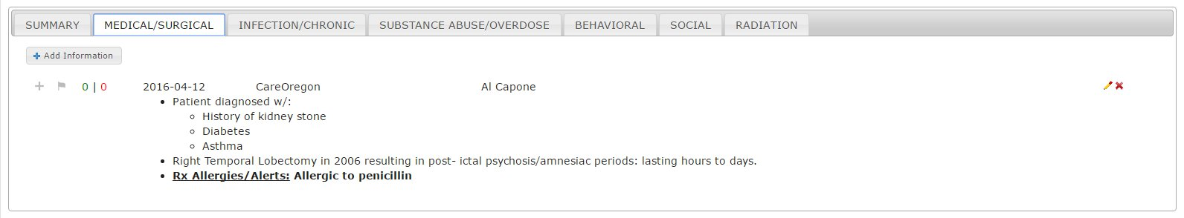

The second section is INFECTION/CHRONIC

- Limit this section to objective information about:

  - Diagnoses related to Infections/Chronic illness
  - Hospital-acquired infections

See the screenshot below for an example of what this might look like for a patient:

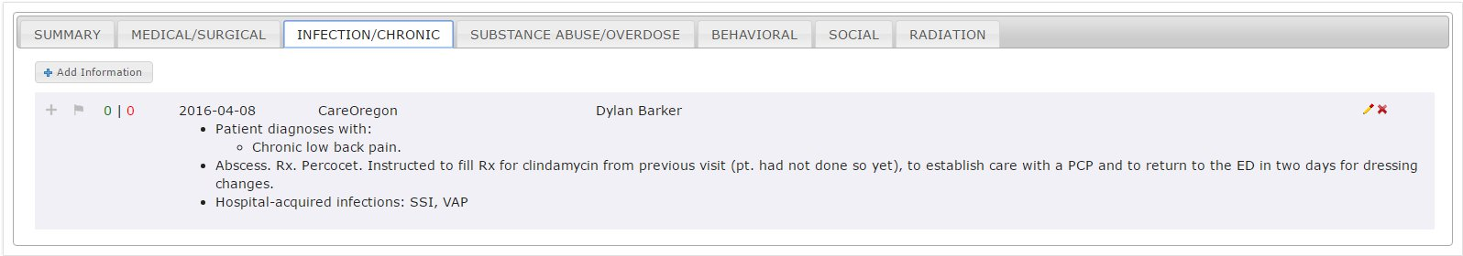

The third section is SUBSTANCE ABUSE/OVERDOSE
- Limit this section to objective information about:

  - Diagnoses related to substance abuse or overdose risks
  - History of recent drug use based on tox screenings, previous overdose info, etc.
  - Overdose risks associated with current or previous prescriptions
  - Pain contracts: Note that the patient is on a pain contract with brief note about prescriber, e.g., Patient agrees and is on pain contract. Dr. Jones is the only prescriber for patient. This information can also be added in the Pain Management section under Care Recommendations.
  - NOTE: If you are at, or have access to medical records from, a clinic or program that holds itself out to the public as providing drug/alcohol treatment services, DO NOT include information relating to drug/alcohol services for the patient. This means users should not include information about current treatment programs the patient is enrolled in.
See the screenshot below for an example of what this might look like for a patient:

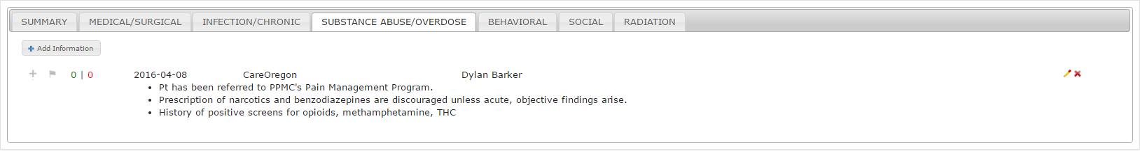

The fourth section is BEHAVIORAL
- Limit this section to objective information about:
  - Diagnoses related to patient’s behavioral health
  - The patient’s baseline presentation
    - Use bold/italics/underline to emphasize information
    - Include key, current medications that may affect care and treatment in the ED
  - Advisories or alerts that might be critical for ED to know
  - Behavioral contracts: Note that the patient is on a BH contract with a brief description or enrolled in relevant community support programs
  - NOTE: This tab is an idea place for BH professionals to contribute background information (such as key crisis plan information) about the patient to inform the entire care team.
See the screenshot below for an example of what this might look like for a patient:

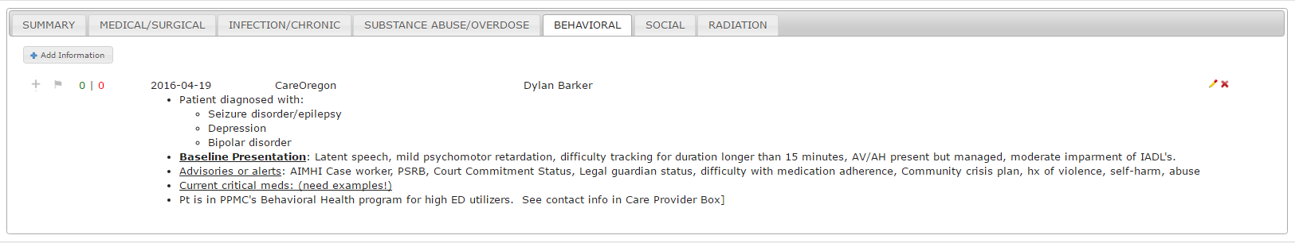
The fifth section is SOCIAL

- Limit this section to objective information about:

  - Social/Community services available to the patient
    - Make sure to include relevant contact information
  - Patient’s living conditions
  - Patient’s primary care givers
  - Any cultural/linguistic background that might be helpful
  - NOTE: For care managers/case workers who have sensitive information to share (e.g., history of domestic violence), please include your contact information in the Care Provider box so that ED providers can call you to discuss. This is to ensure patient safety while complying with all related state and federal rules, regulations and guidelines.
See the screenshot below for an example of what this might look like for a patient:
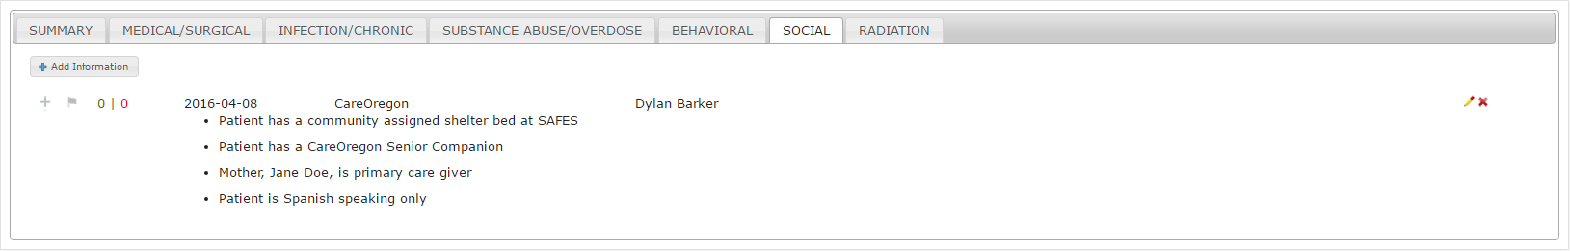

The sixth and final section is RADIATION

- Limit this section to objective information about:

  - Patient’s radiation history
    - Number of X-Rays in a given timeframe
    - Number of CT scans in a given timeframe
    - Any additional radiation exposure that would be helpful for the ED to be aware of.
  - Any objective findings that have come from these scans

See the screenshot below for an example of what this might look like for a patient:
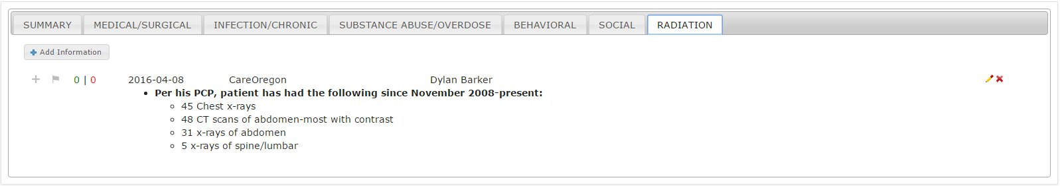
Patient Background – Summary Level
- The Summary tab pulls all Patient Background information together in one tab (users cannot enter information into the Summary tab). As various users add information to the tabs, the most current entry will load at the top.

- See example of the Patient Background Summary on the following page.
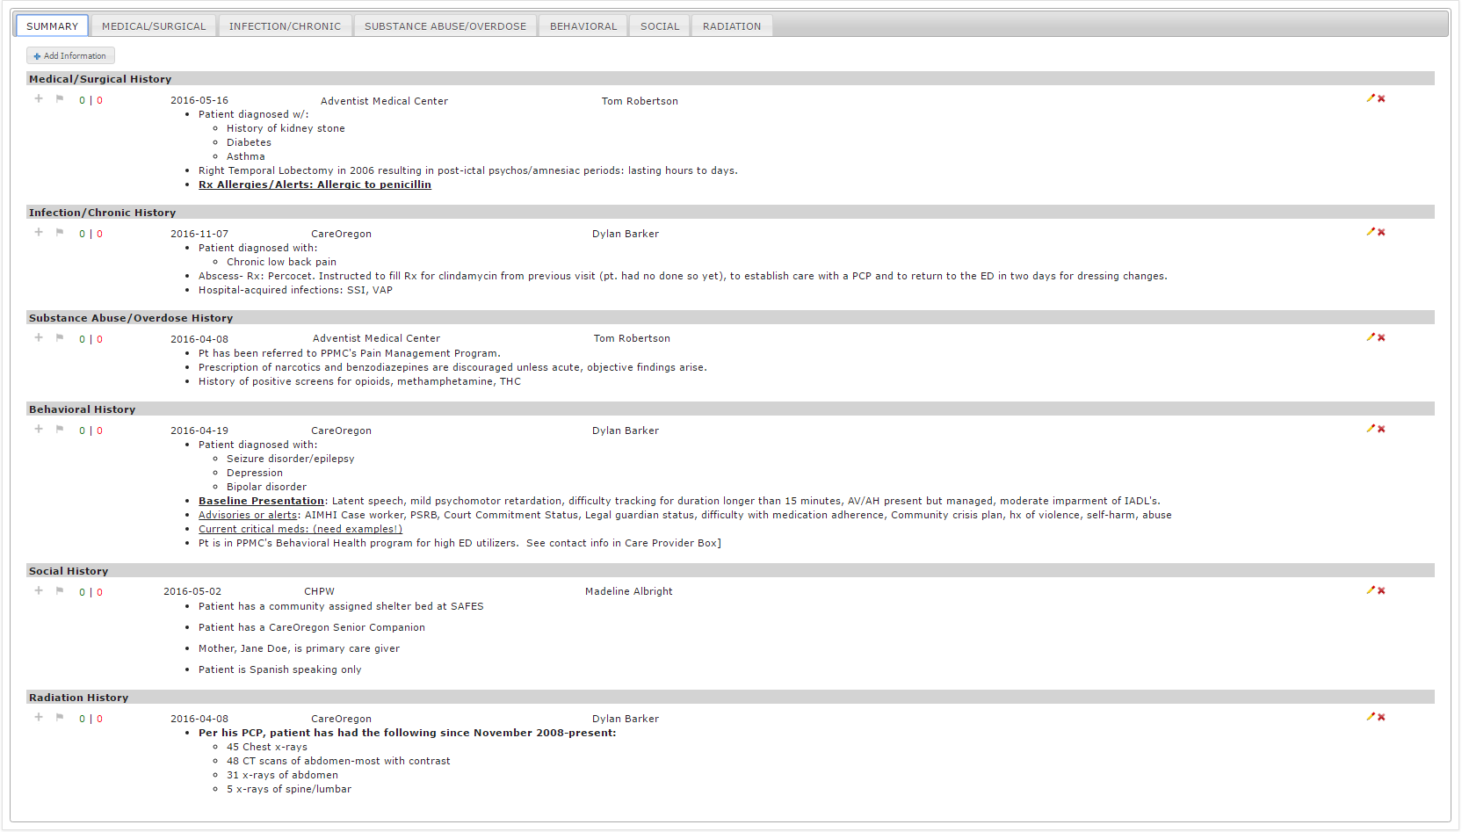
Patient Background – Voting/Flagging Info
In the patient background section, you have the ability to vote or flag information. This allows you to quickly collaborate with other EDIE/PreManage users. To do this, simply click the icon if you agree with the information presented or the icon if you disagree with the information. If you click the flag, it will immediately send the individual who authored this information an email inviting them to update information.
Note: If the user who input the information no longer has access to PreManage, the outdated information will still continue to appear. Contact CMT for assistance in these situations by using the Support tab in PreManage.
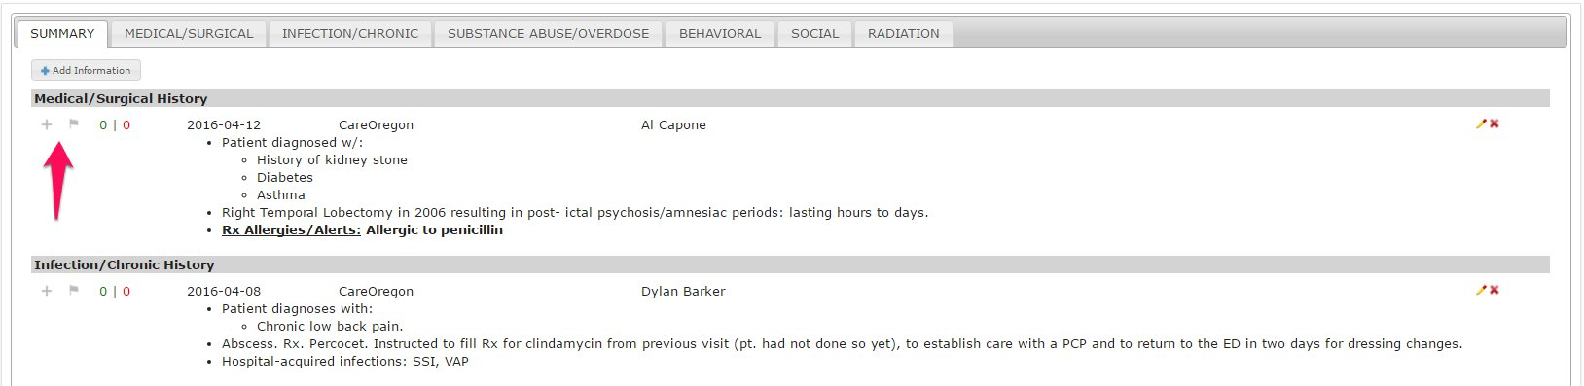

Adding a Care Recommendation
The Care Recommendation Section is a powerful part of PreManage intended to deliver brief, critical information to ED providers at the point of care (i.e., info delivered in a hallway conversation). When a Care Recommendation is created, it will trigger an alert to be sent to the ED when the patient presents

Organizational Roles

Care Provider Data Entry*:  - PreManage care manager/coordinator (primary care, behavioral health, plan)  - ED care managers/coordinators | Priority Audience (Data Consumers):  - ED Provider

NOTE: CMT is actively working to improve the functionality for Care Recommendations to allow for more collaboration across users and to work towards the ideal of one Care Recommendation per patient. Stay tuned for updates to this feature.

NOTE: Ideally there should be one care recommendation for each patient, developed by the individual who has the most first-hand knowledge of the patient in collaboration with others who are involved in their care.

NOTE: Care Recommendation authors are encouraged to keep the recommendations up to date (e.g., review and update guidelines every 3-6 months) in collaboration with a patient’s care team. Care Recommendations remain viewable in a patient record for 18 months without updates. After that time, they are no longer sent to the ED but remain attached to the patient’s record.

There are 5 different subsections that allow you to organize the type of information you’d like to include:

NOTE: Even if only one of the five subsections is completed (see below), this will trigger the delivery of the Care Recommendation to the ED. Therefore, you don’t need to complete all sections for the information to be sent.

- Care Recommendation: (A recommendation for how a condition should be treated or has been successfully treated in the past)

- Care Coordination: (An explanation of the coordinated efforts in regard to this patient's care)

- Pain Management: (A recommendation for how the patient's pain should be managed, including pain contracts, etc.)

- Helpful ED-Based Interventions to Try: (A list of helpful interventions that have been successful in prior ED visits.)

- Other Information: (Any additional information relevant for the ED).
  - NOTE: This section should be used with caution as the most relevant patient information can likely fit into one of the above Patient Background Tabs or other Care Recommendations sections.

To add a Care Recommendation, click the button that says “Add ED Care Guidelines”
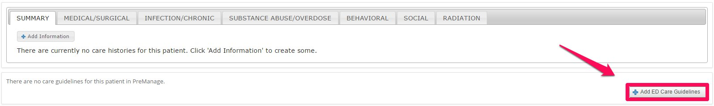

This is what it will look like once you click the button:
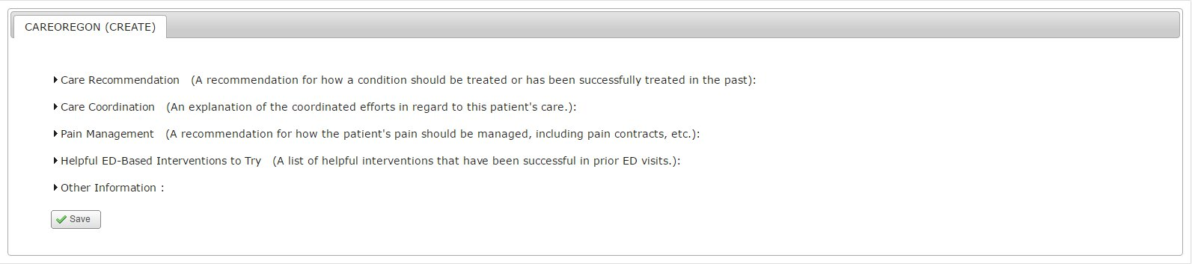

Care Recommendations Section

This is a place to create a recommendation for how a condition should be treated or has been successfully treated in the past. Or in other words, “Based on the above objective Patient Background information, this is the recommended care for the patient…”

Simply click where it says “Care Recommendation” to create one.
What should be included in this section?
- Patient goals for care
- Team recommendations for how the ED should treat a patient when they present
- Details about care the patient is currently receiving in an outpatient setting to help redirect them to the outpatient care plan

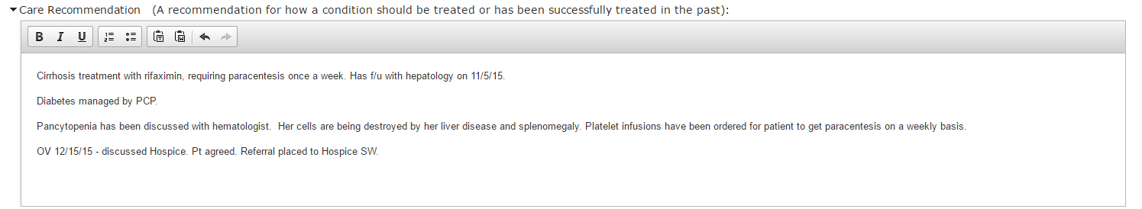

Care Coordination Section

Use this section to provide an explanation of the coordinated efforts around a patient’s care.
NOTE: Members of a patient’s care team along with contact information should be listed in the Care Provider box (explained above). The Care Coordination section here is intended to provide additional information about a provider’s relationship with the patient. A good rule of thumb is you need to add context about a provider’s relationship with a patient for entries in this section.

What should be included in this section?
- Additional context about the relationship as appropriate, e.g., previous efforts to coordinate care for the patient
- See example below for additional details

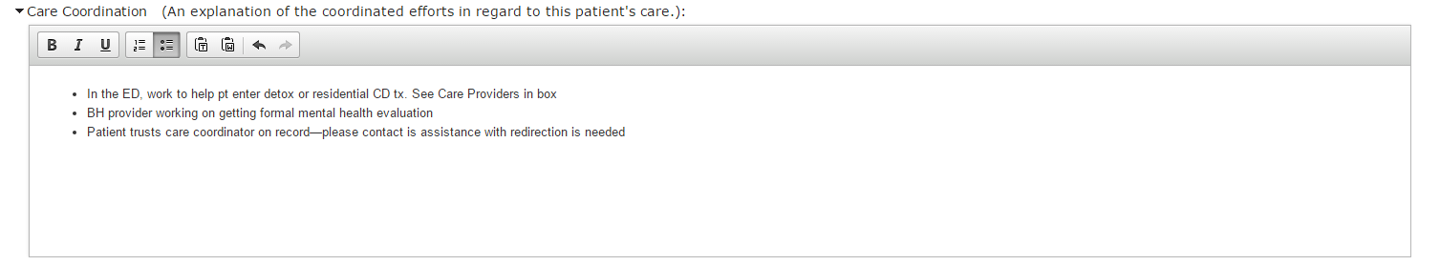
Pain Management Section

This is a place to provide a recommendation for how the patient’s pain should be managed, including key highlights from any pain contracts, etc.

What should be included in this section?

- If the patient has an active pain contract with their PCP, this is a great place to add key details about the contract, including who the sole prescriber is for the patient.
- Mention appropriate pain medications and dosing in this section
- See example below for additional details

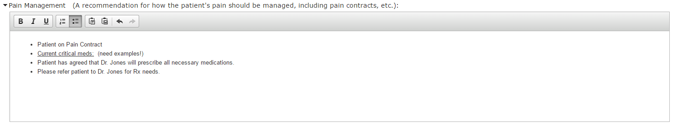

Helpful ED Interventions to Try

Use this section to provide a list of helpful interventions that have been successful in prior ED visits.

What should be included in this section?

- Any helpful information you may have about previous ED interventions that have worked
- Specific tips/strategies for interacting with the patient
- See example below for additional details.

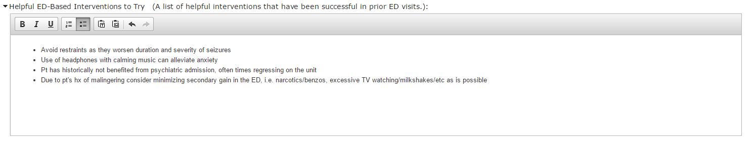

Organization-Specific Templates
Some organizations have opted to create custom templates for their care recommendations—including those hospitals that are pushing care recommendations directly into EDIE/PreManage from their EMR. An example of a custom template care recommendation from Sound Mental Health for is below:
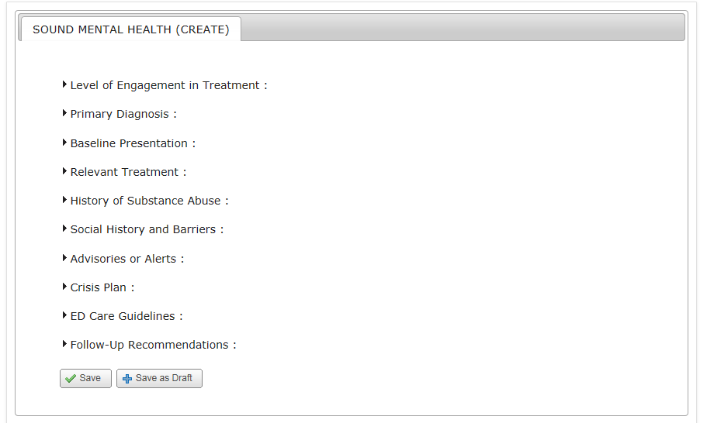

Complete Patient Record

- Note to ED Providers and ED Care Managers/Care Coordinators: Every hospital has the ability to customize their Patient Record view in EDIE to find the view that works best for your team. However, to foster care coordination, EDIE notifications should display the most recent care recommendation regardless of author. Contact your CMT CRM to adjust and refine your view.

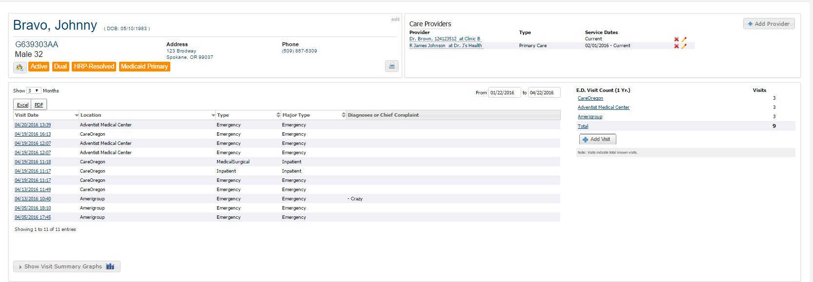

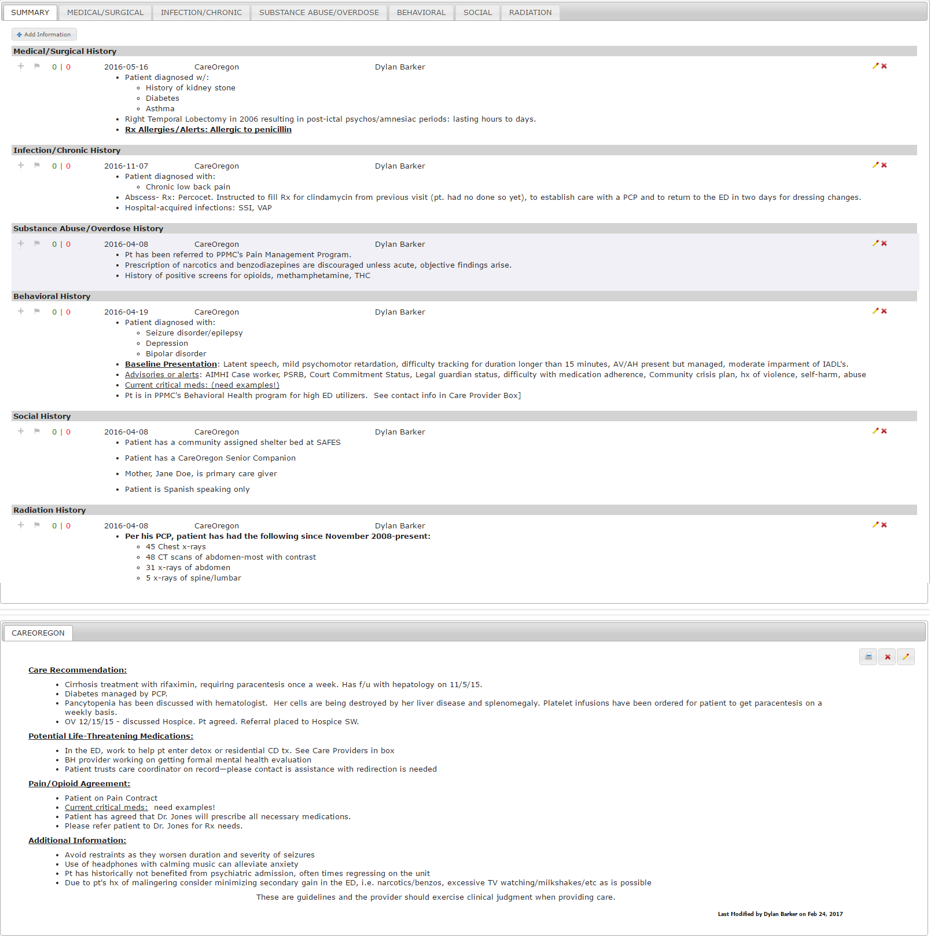

Security Events

Security events can be entered in the EDIE or PreManage patient record to flag events that may lead to patient or hospital staff safety concerns. The Security Event section is located below the Care Recommendations section. Click Add Security Event to get started.

You can associate the security event with a particular hospital encounter, or if you are a PreManage user, you can leave it unassociated. The Security Event Type is a drop down menu—pick the closest type of security event to what you want to flag. Hospitals can filter out specific kinds of security events in their notifications (e.g. they could filter out elopement if they do not want to be alerted on this type of security event.

The Details box allows you to share a brief narrative associated with the event—try to briefly explain the objective facts of the security event. You can choose to share a security event with the entire EDIE/PreManage network or just your own organization. Click save to finish the security event.

The security event is its own section in the EDIE notification in the ED. Many hospitals have chosen to put this section at the very top of their notifications. Hospitals can also trigger a notification off of a security event or push the notification directly to the ED security desk. The following shows what a security event looks like in a notification:

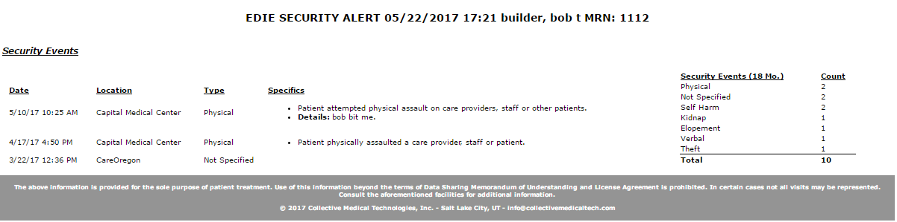

Reminders about Information Sharing

Sensitive Information

Please refer to CMT’s Sensitive Information Policy, available here: http://collectivemedicaltech.com/about-us/cmt-policies/

Limit Use of Acronyms

Because PreManage is used by a wide range of providers and others involved in patient care, users should limit their use of acronyms throughout PreManage— “when in doubt, spell it out.”
- Well-known medical acronyms are OK

Contact Information

For technical questions about using this Care Recommendations Template, please contact:

Justin Keller
Director, Network Operations
Collective Medical Technologies, Inc.
Email: Justin.keller@collectivemedicaltech.com
http://www.collectivemedicaltech.com

Appendix: Examples of Patient Background and Care Recommendations
TBD following 3/1 meeting

